# COMP 421

# DATABASE SYSTEM

# ONLINE BOOK STORE DATABASE

## ILAN BEN-BRITH 260478181

## JUSTIN DOMINGUE 260588454

## DANIEL PHAM 260526252

# 1. Relational Schema

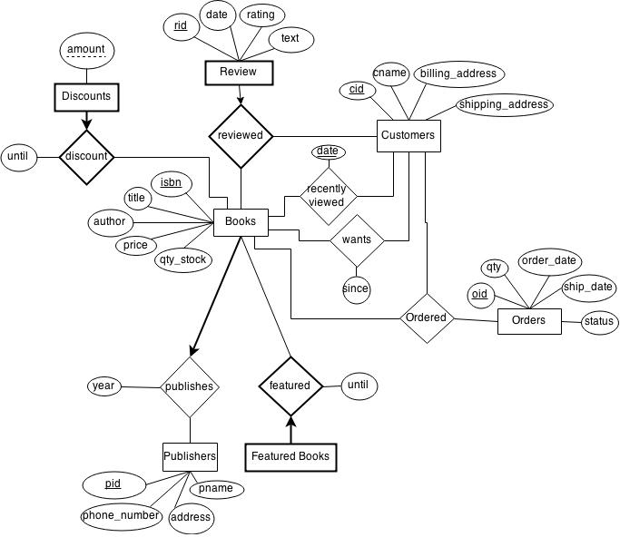

## Entities

Customer(cid, cname, billing_address, shipping_address)

Books(isbn, title, author, price, qty_stock)

Orders(oid, qty, order_date, ship_date, status)

Publisher(pid, pname, phone_number, address)

## Weak Entities

Reviews(isbn, cid, text, rating, date)

Discounts(amount, isbn, until)

FeaturedBooks(isbn, until)

## Relationships

Ordered(oid, cid, isbn)

Wants(cid, isbn, since)

RecentlyViewed(cid, isbn*,* date)

Publishes(pid, isbn, year)

# 2. SQL Database Schema

## Create statements

See file 1-create.sql for the CREATE TABLE statements.

We could express all constraints.

## Table descriptions

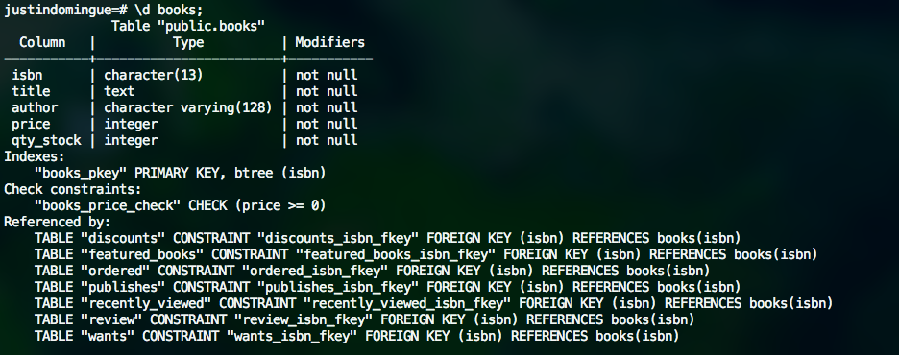

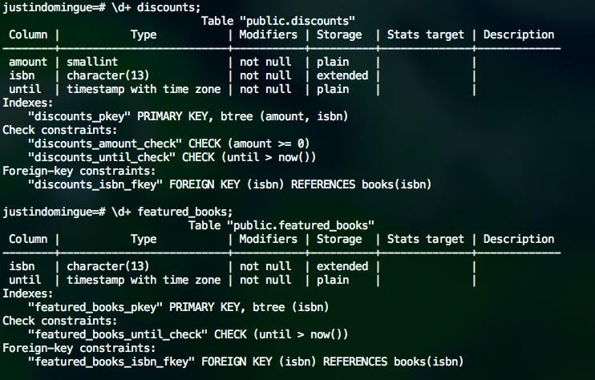

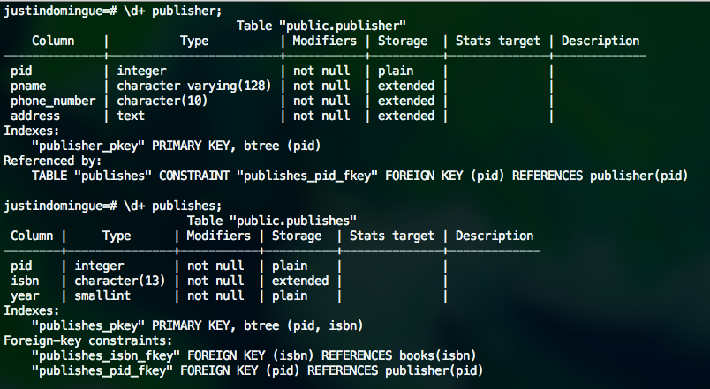

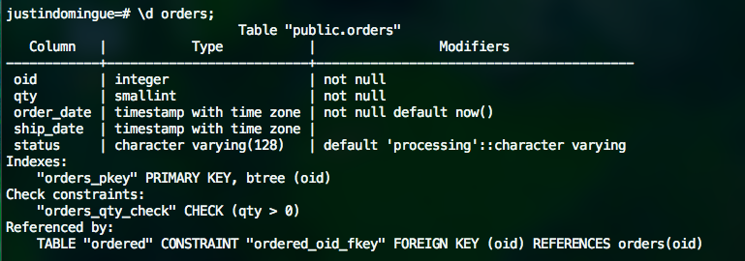

# Macintosh HD:Users:justindomingue:Desktop:Screen Shot 2015-03-09 at 7.20.19 PM.png

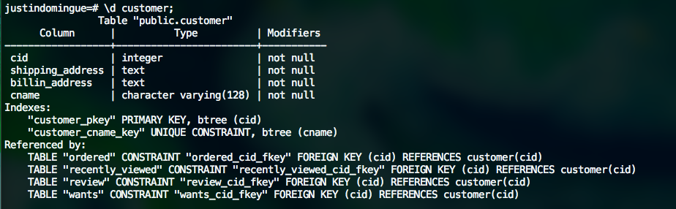

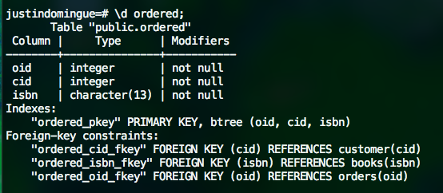

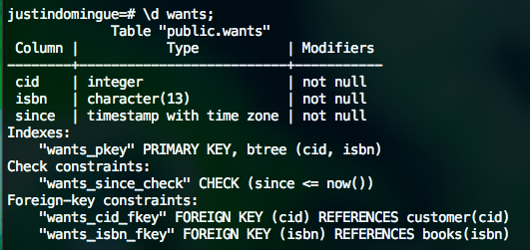

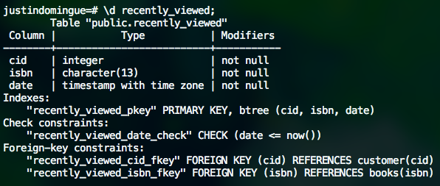

# 3. Data Insertion

## Insert statements

See file 2-inserts.sql for the INSERT statements

## Postgresql output

TODO

## Select * from output

TODO

# 4. More Data Insertion

See file 4.sql for the SQL statements.

Here is the output of SELECT * FROM for each table.

## books

TODO same for the rest

## customers

## orders

## publisher

## review

## featured_books

## wants

## ordered

## publishes

# 5. Queries

## Description of all the relations used

TODO

## Queries

See file 5-queries and their description

## Execution

Here is a screenshot of the execution of the script. From the data inserted before, you should be convinced that the queries are executing properly.

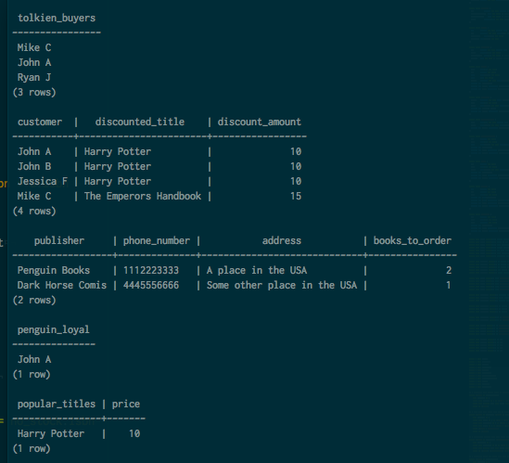

# 6. Data Modification Commands

## Description of all the relations used

## Macintosh HD:Users:justindomingue:Desktop:Screen Shot 2015-03-09 at 7.11.05 PM.png

## Macintosh HD:Users:justindomingue:Desktop:Screen Shot 2015-03-09 at 7.12.19 PM.png



## Modification commands

See file 6-modifications.sql for the modification commands along with their description.

## Execution

Modification 1: Update orders for which the quantity in stock for the ordered book is less than the quantity ordered. (the select statements show the order in the system. The last 3 records have an quantity that is greater than the quantity in stock. After executing the command, their status have changed to “restocking”, as expected.)

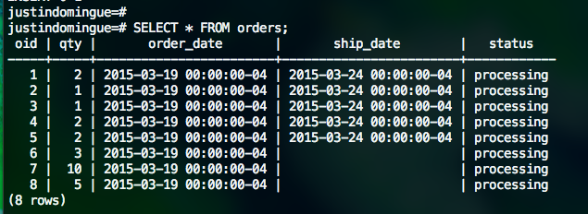

-- execute modification command

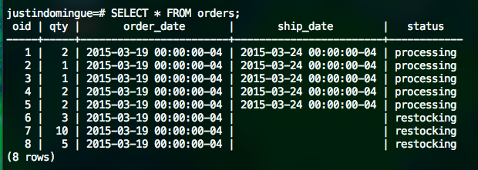

Modification 2: delete inactive publishers – (the select shows the active publishers. Then the modification query is executed, deleting 3 publishers, none of which is an active publishers as shown by the repetition of the select. The only remaining publishers are the active ones as shown by the last select)

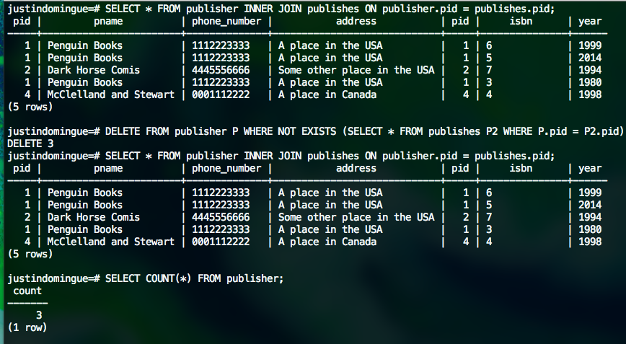

Modification 3 : inserts (after executing the query, all the discounted books are also featured_books. Also note that no error was reported for book 1 and 3 which were already both discounted and featured, as expected).

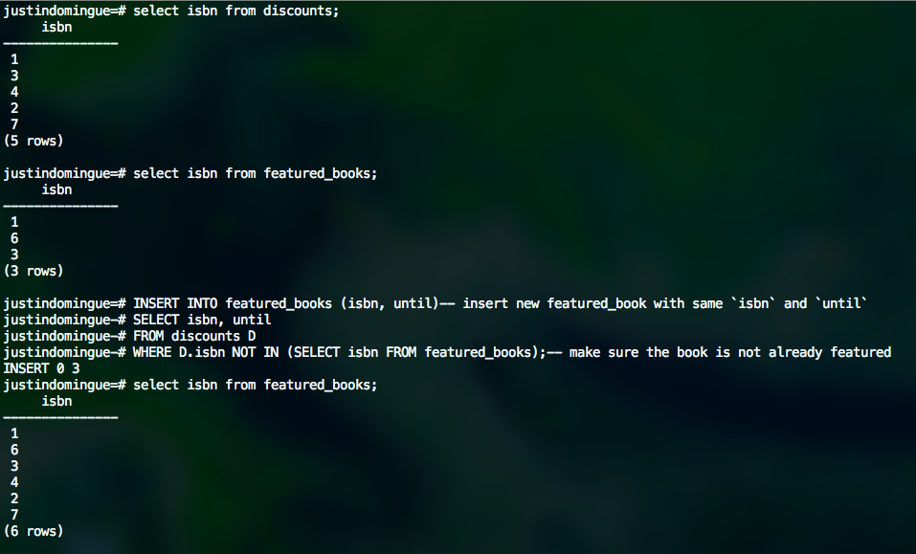

Modification 4: update price of books published by Penguin Books by a fixed amount, here, 5. (the two selects are identical. They show the price of each book published by Penguin Books. As expected, after exectuting the modification command, all the prices have increased by 5$.)

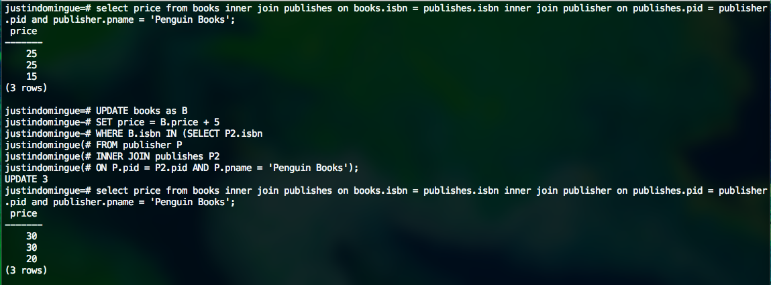

# 7. Views

## Create view statements

See file 7-views.sql for the CREATE VIEW statements along with a description of each view.

## Response of the system

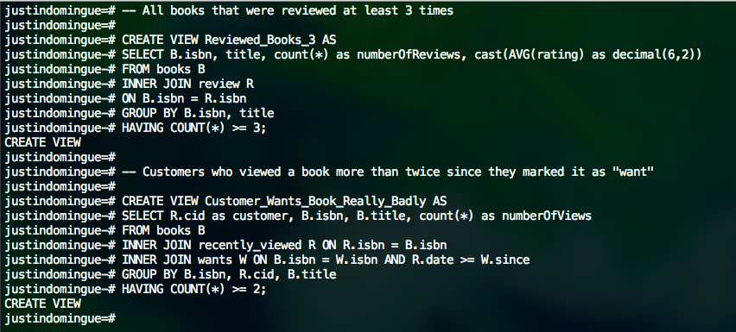

## Execution

# Macintosh HD:Users:justindomingue:Desktop:Screen Shot 2015-03-09 at 7.06.30 PM.png

# 8. Check Constraints

## Alterations and response

See file 8-check-constraints.sql for the new constraints definition, the system response and examples of modifications that violate the constraints (with the system response).